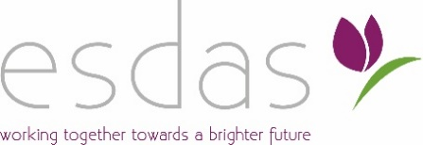
Terms & Conditions
​
​1. Accuracy
East Surrey Domestic Abuse Services (ESDAS) makes every effort to ensure that the information on this website is accurate and up-to-date. However, we cannot accept responsibility for any loss or inconvenience caused by reliance on inaccurate material contained in this site. Links to other sites are provided for your convenience and do not imply East Surrey Domestic Abuse Services' endorsement of them. We cannot be responsible for information contained on other sites.

2. Copyright
All material on this site (including text and images) is, unless otherwise stated, the copyright of East Surrey Domestic Abuse Services. Educational use (within the classroom) is permitted provided that no changes are made to the material and East Surrey Domestic Abuse Services is acknowledged as the owner. Commercial usage is prohibited unless formal written permission is obtained beforehand.

3. Privacy
Parts of this website use cookies. Any personal information collected from visitors to this site is used only anonymously to monitor site usage. Eg we may use software tools to measure and collect session information including page response times, length of visits to certain pages, page interaction information and methods used to browse away from the page. No personal information from this site is stored by ESDAS or disclosed to third parties and is held under the provisions of the GDPR.

4. Limitation of Liability
4.1 To the maximum extent permitted by law, ESDAS accepts no liability for any direct or indirect loss or damage, foreseeable or otherwise, including any indirect, consequential, special or exemplary damages arising from the use of the Web Site or any information contained therein. Users should be aware that they use the Web Site and its Content at their own risk.

4.2 Nothing in these terms and conditions excludes or restricts ESDAS’ liability for death or personal injury resulting from any negligence or fraud on the part of ESDAS .

5. Law and Jurisdiction
These terms and conditions and the relationship between you and ESDAS shall be governed by and construed in accordance with the Law of England and Wales and ESDAS and you agree to submit to the exclusive jurisdiction of the Courts of England and Wales.

